# *Chapter Four Hands-On-Assignments*

1. For the ENROLL table add a composite primary key made up of the columns CLASS_CODE and STU_NUM

Cut and paste your SQL Statements that you used to create your tables here:

Alter table Enroll add constraint CLASS_CODE_STU_NUM_PK primary key(CLASS_CODE, STU_NUM);

Attach screen shots of your table data here.

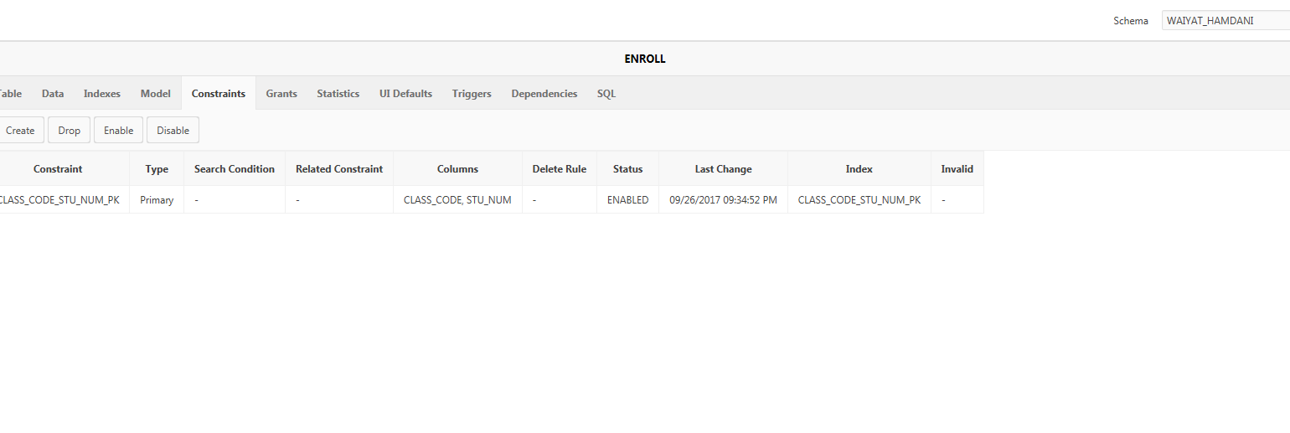

1. For the STUDENT table add a primary key made up of the student number.

Cut and paste your SQL Statements that you used to create your tables here:

Alter table STUDENT add constraint STU_NUM_PK primary key (STU_NUM);

Attach screen shots of your table data here.

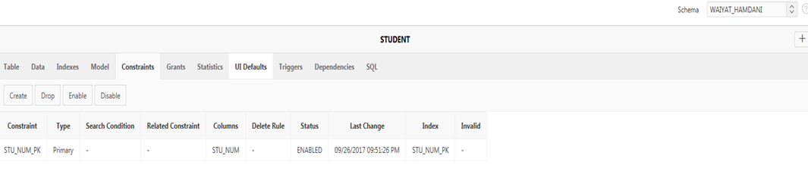

1. Modify the following SQL command so that PROF_NUM column is the PRIMARY KEY for the table. Run the DDL command to create the table PROFESSOR.

CREATE TABLE PROFESSOR

(

PROF_NUM NUMBER(3),

Professor_last_name VARCHAR2(150),

Professor_first_name VARCHAR2(100),

email VARCHAR2(30),

Phone_num VARCHAR2(30),

);

Cut and paste your SQL Statements that you used to create your tables here:

*CREATE TABLE PROFESSOR(*

*PROF_NUM NUMBER(3),*

*Professor_last_name VARCHAR2(150),*

*Professor_first_name VARCHAR2(100),*

*email VARCHAR2(30),*

*Phone_num VARCHAR2(30), primary key(PROF_NUM));*

Attach screen shots of your table data here.

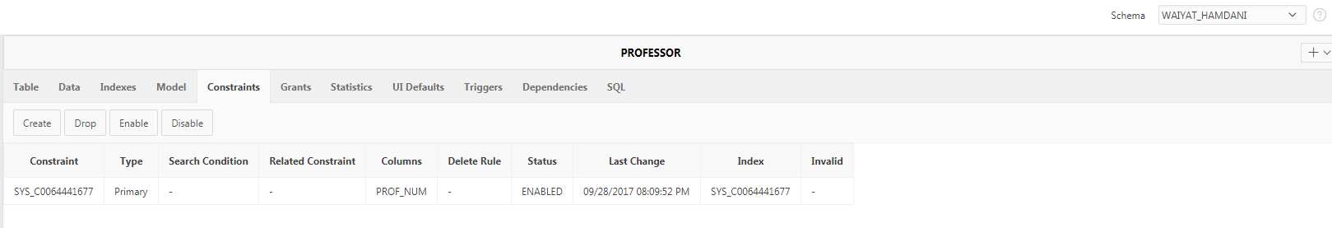

When you are done with question #3 either cut and paste the below commands or down load the file “Insert data into professor table.sql” from Blackboard Learn/ Chapter 4 Constraints and run it.

INSERT INTO professor VALUES (199,'Whitfield','Castor','Bruce@Curae.com','427-738-6402');

INSERT INTO professor VALUES (205,'Frank','Leah','Ferris@purus.gov','306-903-1736');

INSERT INTO professor VALUES (228,'Knapp','Tate','Irma@sagittis.com','966-173-6133');

INSERT INTO professor VALUES (311,'Baird','Cole','Thor@Cum.com','126-338-1153');

INSERT INTO professor VALUES (230,'Frank','Aladdin','Raya@congue.edu','305-698-7596');

INSERT INTO professor VALUES (222,'Camacho','Harper','Kameko@euismod.net','325-063-9891');

INSERT INTO professor VALUES (105,'Cameron','Callum','Norman@venenatis.com','591-389-5065');

INSERT INTO professor VALUES (342,'Herring','Aurelia','Winifred@malesuada.net','857-413-6680');

INSERT INTO professor VALUES (301,'Olsen','Ocean','Robert@lacus.gov','882-885-0752');

INSERT INTO professor VALUES (279,'Dodson','Clementine','Destiny@cursus.org','762-481-5892');

INSERT INTO professor VALUES (114,'Porter','Virginia','Gisela@gravida.net','062-151-2032');

INSERT INTO professor VALUES (162,'Hanson','Gray','Dacey@morbi.us','635-455-5435');

INSERT INTO professor VALUES (287,'Robles','Julie','Jennifer@mus.gov','913-069-7465');

INSERT INTO professor VALUES (243,'Drake','Mohammad','Connor@tempus.edu','594-255-9405');

INSERT INTO professor VALUES (245,'Payne','Larissa','Eliana@Quisque.edu','048-597-2398');

INSERT INTO professor VALUES (261,'Rich','Nigel','Edward@id.us','631-053-3860');

INSERT INTO professor VALUES (240,'Joyce','Vance','Carl@diam.gov','705-080-4962');

INSERT INTO professor VALUES (249,'Christian','Bernard','Autumn@accumsan.gov','063-362-2435');

INSERT INTO professor VALUES (256,'Gentry','Len','Daniel@interdum.org','480-608-1786');

INSERT INTO professor VALUES (307,'Dominguez','Deborah','Wilma@nisi.edu','673-806-0293');

1. For the STUDENT table add a foreign key made up of the PROF_NUM:

Cut and paste your SQL Statements that you used to create your tables here:

alter table STUDENT add constraint PROF_NUM_FK foreign key (PROF_NUM) references PROFESSOR(PROF_NUM);

Attach screen shots of your table data here.

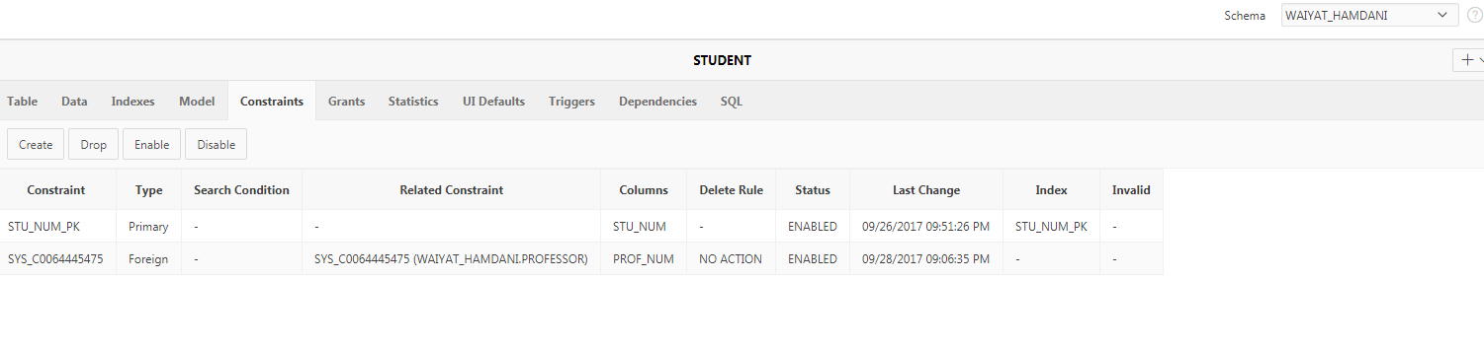

1. Change the ENROLL table so that only a grades of A+, A, A-, B+, B, B-, C+, C, C-, D+, D, D-, and F can be entered it the ENROLL_GRADE column.

Cut and paste your SQL Statements that you used to create your tables here:

*alter table ENROLL add constraint ENROLL_GRADE_CK check(ENROLL_GRADE in('A+', 'A', 'A-', 'B+', 'B', 'B-', 'C+', 'C', 'C-', 'D+', 'D', 'D-','F'));*

Attach screen shots of your table data here.

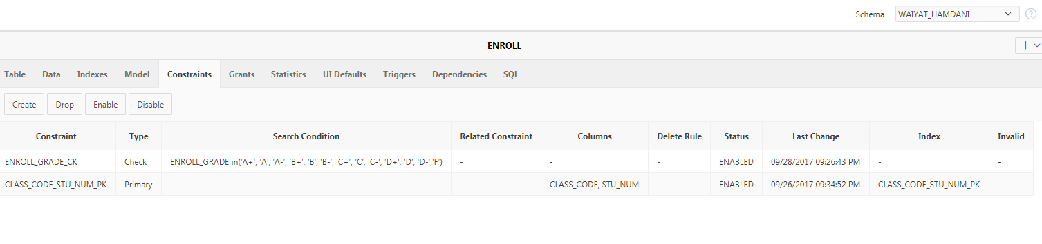

1. Run the following DDL command to insert data into the student table. DO NOT JUST CUT AND PAST THE ERROR REPORT FROM APEX! I want to know why in your own words.

INSERT INTO STUDENT VALUES (654320,'Vadar','Darth','', '30-oct-55', 40, 'FR', 4.00, 'false', 'CIS', 2222, 231);

*ORA-02291: integrity constraint (WAIYAT_HAMDANI.SYS_C0064445475) violated - parent key not found=*

The table between student and professor indeed connected to each other. That is because we create foreign key in number four. However, in the professor table the data 231 it doesn’t exist.